**A Minor Project Report**

**on**

Library Website

Submitted in partial fulfillment of requirements for the award of the

Degree of

Bachelor of Technology

In

Computer Science and Engineering

Under the guidance of

**Ms. Ramanpreet Kaur**

Submitted By

**Bikramdeep Singh**

(1702594)



**DEPARTMENT OF COMPUTER SCIENCE AND ENGINEERING**

**CHANDIGARH ENGINEERING COLLEGE**

**LANDARAN. PUNJAB**

**MONTH, YEAR**

**CERTIFICATE**

This is to certify that this project has been made by BIKRAMDEEP SINGH of section-C on the topic “LIBRARY WEBSITE” under the guidence of our teacher MrS. SHUBPREET KAUR and have been completed it successfully.

Yours truely

Bikramdeep Singh

**ACKNOWLEDGMENT**

I am grateful to Almighty for giving me the strength to successfully conduct my project. I thank him for sustaining my efforts which many times did oscillate.

I feel deeply indebted to Mrs. Ramanpreet Kaur without whose constructive feedback this project would not have been a success. The valuable advice and suggestions for the corrections, modification and improvement did enhance the perfection in performing my job well.

I show my gratitude to Dr.Vikas Dhawan, our principal for providing the best of facilities and environment to bring out our innovation,talent and spirit of inquiry through this project.

**TABLE OF CONTENTS**

· Cover and Title Page

· Certificate

· Acknowledgement

1. Abstract

2. Explaining the project work

2.1 Techniques Used

2.2 Softwares Used

2.3 Flow Chart With Description

3. Coding

4. Results (Screenshots of webpage)

4.1 Home

4.2 About Us

4.3 Explore

4.4 Biographies

4.5 Contact Us

5. Reference

**ABSTRACT**

**LIBRARY WEBSITE**

A library is a location on a site where you can create, collect, update, and manage files with team members. Each library displays a list of files and key information about the files, which helps people to use the files to work together. You can customize libraries in several ways.

You can customize libraries in several ways. You can control how documents are viewed, tracked, managed, and created. You can track versions, including how many and which type of versions, and you can limit who can see documents before they are approved.You can choose from several types of libraries, depending on the types of files that you want to store and how you plan to use them.

A library's collection can include books, periodicals, newspapers, manuscripts, films, maps, prints, documents, microform, CDs, cassettes, videotapes, DVDs, Blu-ray Discs, e-books, audiobooks, databases, and other formats.

Library websites can offer:

1. Interaction with the library catalog.

2. Gateway to electronic resources.

3. Library tutorials.

4. Library blogs.

**Explaining the project work**

**TECHNIQUES USED**

**HTML(Hyper Text Markup Language)**

Hypertext Markup Language (HTML) is the standard markup language for creating web pages and web applications. With Cascading Style Sheets (CSS) , it forms a triad of cornerstone technologies for the World Wide Web.

Web browsers receive HTML documents from a web server or from local storage and render the documents into multimedia web pages. HTML describes the structure of a web page semantically and originally included cues for the appearance of the document.

HTML elements are the building blocks of HTML pages. With HTML constructs, images and other objects such as interactive forms may be embedded into the rendered page. HTML provides a means to create structured documents by denoting structural semantics for text such as headings, paragraphs, lists, links quotes and other items. HTML elements are delineated by tags, written using angle brackets. Tags such as <img /> and <input /> directly introduce content into the page. Other tags such as <p> surround and provide information about document text and may include other tags as sub-elements. Browsers do not display the HTML tags, but use them to interpret the content of the page.

**CSS (Cascading Style Sheets )**

Cascading Style Sheets (CSS) is a style sheet language used for describing the presentation of a document written in a markup language like HTML. CSS is a cornerstone technology of the World Wide Web, alongside HTML and JavaScript. CSS is designed to enable the separation of presentation and content, including layout, colors, and fonts. This separation can improve content accessibility, provide more flexibility and control in the specification of presentation characteristics, enable multiple web pages to share formatting by specifying the relevant CSS in a separate .css file, and reduce complexity and repetition in the structural content.

**SOFTWARE USED**

**NOTEPAD**

Notepad is a simple text editor for Microsoft Windows and a basic text-editing program which enables computer users to create documents. It was first released as a mouse-based MS- DOS program in 1983, and has been included in all versions of Microsoft Windows.

**WEB BROWSER(commonly used google chrome and Mozilla firefox)**

A web browser (commonly referred to as a browser) is a software application for accessing information on the World Wide Web. Each individual web page, image, and video is identified by a distinct URL, enabling browsers to retrieve and display them.

**FLOW CHART WITH DESCRIPTION**

**VISION LIBRARY**

**CONTACT US**

**HOME**

**ABOUT US**

**BIOGRAPHIES**

10 FAMOUS INDIAN AUTHORS

INSPIRING INDIAN BIOGRAPHIES

GEMS OF INDIAN LITERTURE

MISSION AND VISION

LIBRARY

**EXPLORE**

APPLIED SCIENCE

CIVIL ENGINEERING

COMPUTER SCIENCE ENGINEERING

ELECTRICAL &ELECTRONIC ENGINEERING

MECHANICAL ENGINEERING

**Coding**

<html>

<head>

<title>

library website

</title>

<style type="text/css">

#search{

width: 200px;

padding: 7px;

border: 1px solid #333;

}

#submit

{

padding: 7px;

background: creame;

}

.bikram{background-color:rgba(0,0,0,0.8); height:60px; width:100%; line-height:60px;}

</style>

</head>

<body style="margin:10px 50px 50px 50px;" >

<body background="C:\Users\BIKRAM SAINI\Desktop\bikram\main page\c.jpg">

<table>

<th><img src="C:\Users\BIKRAM SAINI\Desktop\bikram\main page\4.jpg" align="left" width="400" height="200"></img></th>

<th bgcolor="#000066" align="right" height="200" width="1000"><center><font face="Constantia" size="8" color="white">A Room Without Books Is Like A Body Without Soul</font></center></th></table>

<hr size="4" width="100%" align="center" color="red">

<div class="bikram">

&nbsp;

<a href="C:\Users\BIKRAM SAINI\Desktop\bikram\main page.html"><font color="aqua">Home</font></a>

&nbsp;

<select onchange="window.location=this.options[this.selectedIndex].value">

<option value='none' selected>About Us</option>

<option value="C:\Users\BIKRAM SAINI\Desktop\bikram\mission and vision.html">Mission & Vision</option>

<option value="C:\Users\BIKRAM SAINI\Desktop\bikram\about library.html">Library</option>

</select>

&nbsp;

<select onchange="window.location=this.options[this.selectedIndex].value">

<option value='none' selected>Explore</option>

<option value="C:\Users\BIKRAM SAINI\Desktop\bikram\applied science.html">Applied Science</option>

<option value="C:\Users\BIKRAM SAINI\Desktop\bikram\civil engineering.html">Civil Engineering</option>

<option value="C:\Users\BIKRAM SAINI\Desktop\bikram\computer science engineering.html">Computer Science Engineering</option>

<option value="C:\Users\BIKRAM SAINI\Desktop\bikram\electrical and electronic engineering.html">Electrical & Electronic Engineering</option>

<option value="C:\Users\BIKRAM SAINI\Desktop\bikram\mechanical engineering.html">Mechanical Engineering</option>

</select>

&nbsp;

<select onchange="window.location=this.options[this.selectedIndex].value">

<option value='none' selected>Biographies</option>

<option value="C:\Users\BIKRAM SAINI\Desktop\bikram\10 famous indian authors.html">10 Famous Indian Authors</option>

<option value="C:\Users\BIKRAM SAINI\Desktop\bikram\inspiring indian biographies.html">Inspiring Indian Biographies</option>

<option value="C:\Users\BIKRAM SAINI\Desktop\bikram\must read gems of indian literature.html">Gems Of Indian Literature</option>

</select>

&nbsp;

<a href="C:\Users\BIKRAM SAINI\Desktop\bikram\contact us.html"><font color="aqua">Contact Us</font></a>

<hr size="4" width="80%" align="left" color="red">

</div>

<form align="right">

<input type ="text" placeholder="search..." maxlength="20" id="search">

<input type ="submit" value="Go!" id="submit">

</form>

<table>

<tr>

<th width="1000" ><img src="C:\Users\BIKRAM SAINI\Desktop\bikram\main page\f.jpg" width="940" height="400" ></img></th>

<th>

<table cellpadding="2" width="300" align="center" cellpadding="2" border="2" height="400" bgcolor="#f1f1f1">

<tr>

<td colspan="2">

<h1 align="center"><font face="Microsoft Sans Serif">Sign In</font></h1></td>

</tr>

<tr>

<td>First Name:</td>

<td><input type="text" name="t1">

</tr>

<tr>

<td>Last Name:</td>

<td><input type="text" name="t2">

</tr>

<tr>

<td>Gender</td>

<td><input type="radio" value"male">Male

<input type="radio" value="female">Female</td>

</tr>

<tr>

<td>Email:</td>

<td><input type="text" name="t3"></td>

</tr>

<tr>

<td>Password:</td>

<td><input type="text" name="t4"></td>

</tr>

<tr>

<td>Confirm Password:</td>

<td><input type="text" name="t5"></td>

</tr>

<tr>

<td>State:</td>

<td><select name="state">

<option value="select">Select. . .</option>

<option value="punjab">Punjab</option>

<option value="chd">Chandigarh</option>

</tr>

<tr>

<td colspan="2">

<h2><center><a href="C:\Users\BIKRAM SAINI\Desktop\bikram\successfully signed in.html">Sign up</a></h2></td>

</tr>

</table></table>

<br>

<hr size="3" width="100%" align="center" color="red">

<font face="Palatino Linotype" size="5" color="white"><div class=bikram>

<strong><center>

WHY TO READ BOOKS?</center></strong></font></div>

<br>

<font face="" size="4">

Even if you have read one good book in your life, you will know what reading gives. It gives you incomparable pleasure. While there is no doubt about the fact that reading is a priceless activity, it has been observed that the habit of reading has declined of late. One of the main causes for this decline is the growth of technology. However, what most people don’t know is there is so much to benefit from reading.

<br><br>

<b>1: Gives knowledge-</b><br>

<hr size="2" width="30%" align="left" color="white">

One of the biggest reasons why we read books is to gain knowledge. Books are a rich source of information. Reading books on varied subjects imparts information and increases the depth about the subject as well. Whenever you read a book, you learn a new information that otherwise would not have known.<br><br>

<b>2: Improves your brain-</b><br>

<hr size="2" width="30%" align="left" color="white">

Studies have shown that reading has strong positive effects on the brain. By staying mentally stimulated, you can prevent dementia and Alzheimer’s disease. This is because, keeping your brain active prevents it from losing power. The brain is a muscle and like other muscles in the body, exercise keeps it strong and healthy. Similar to solving puzzles, reading books is a great way to exercise your brain and keep it healthy.<br><br>

<b>3: Reduces stress-</b><br>

<hr size="2" width="30%" align="left" color="white">

Reading has a positive effect on the body as well. Reading a book can relieve stress better than taking a walk or listening to music. According to studies who read more tend to have lower stress levels.<br><br>

<b>4: Improves memory-</b><br>

<hr size="2" width="30%" align="left" color="white">

Every time you read a book, you have to remember the setting of the book, the characters, their backgrounds, their history, their personalities, the sub-plots and so much more. As your brain learns to remember all this, your memory becomes better. What’s more, with every new memory you create, you create new pathways and this strengthens the existing ones.

<br><br>

<b>5: Improves imagination-</b><br>

<hr size="2" width="30%" align="left" color="white">

The more you read, the more imaginative you become. Whenever you read a fiction book, it takes you another world. In the new world, your imagination works at its best as you try to see things in your own mind.

<br><br>

<b>6: Develops critical thinking skills-</b><br>

<hr size="2" width="30%" align="left" color="white">

One of the primary benefits of reading books is its ability to develop critical thinking skills. For example, reading a mystery novel sharpens your mind. Critical thinking skills are crucial when it comes to making important day to day decisions. Reading requires an individual to think and process information in a way that watching television can’t. The more you read, the deeper your understanding becomes about what you’re reading and its application.

<br><br>

<b>7: Builds vocabulary-</b><br>

<hr size="2" width="30%" align="left" color="white">

Reading improves your vocabulary and command on the language. As you read, you come across new words, idioms, new words, phrases and writing styles.

<br><br>

<b>8: Improves writing skills-</b><br>

<hr size="2" width="30%" align="left" color="white">

Reading a well-written book affects your ability to become a better writer. Just like artists influence others, so do writers. Many successful authors gained their expertise by reading the works of others. So, if you want to become a better writer, start by learning from previous masters.

<br><br>

<b>9: Improves communication skills-</b><br>

<hr size="2" width="30%" align="left" color="white">

Improving your vocabulary and writing skills goes hand in hand with developing your communication skills. The more you read and write, the better you communicate. Increasing your ability to communicate, improves your relationships and even makes you a better employee or student.

<br><br>

<b>10: Improves focus and concentration-</b><br>

<hr size="2" width="30%" align="left" color="white">

In our busy lifestyles, our attention is drawn in different directions each day as we try to multi-task through each day. For example, you may find yourself dividing your time between working on a task, chatting with people via Skype, checking email, keeping an eye on Facebook and interacting with your colleagues. All this multi-tasking can lead to high stress level and low productivity. When you read a book, all your attention is focused on what you’re reading. Your eyes and thoughts are immersed in the details of the story. This improves your concentration and focus. Read a book at least 20 minutes a day, and you will be amazed at how much more focused you will be.

<br><br>

</font>

<div class=bikram>

<font face="Palatino Linotype" size="5" color="white">

<center>KNOW MORE ABOUT VISION</center></font></div>

<div class="bikram"><center>&nbsp

<a href="https://facebook.com"><font size="5" color="aqua">Facebook</font></a>&nbsp&nbsp&nbsp&nbsp&nbsp&nbsp&nbsp&nbsp&nbsp&nbsp&nbsp&nbsp

<a href="https://twitter.com"><font size="5" color="aqua">Twitter</font></a>&nbsp&nbsp&nbsp&nbsp&nbsp&nbsp&nbsp&nbsp&nbsp&nbsp&nbsp&nbsp

<a href="https://instagram.com"><font size="5" color="aqua">Instagram</font></a>&nbsp&nbsp&nbsp&nbsp&nbsp&nbsp&nbsp&nbsp&nbsp&nbsp&nbsp&nbsp

<a href="https://visionlibrary.com"><font size="5" color="aqua">Website</font></a>&nbsp&nbsp&nbsp&nbsp&nbsp&nbsp&nbsp&nbsp&nbsp&nbsp&nbsp&nbsp

<a href="https://gmail.com"><font size="5" color="aqua">E-mail</font></a>&nbsp

</center>

</div>

</body>

</html>

**Screenshots**

**Home page**

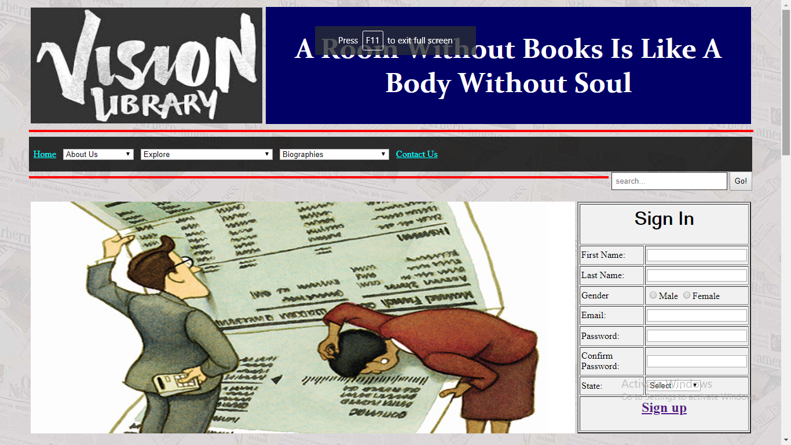

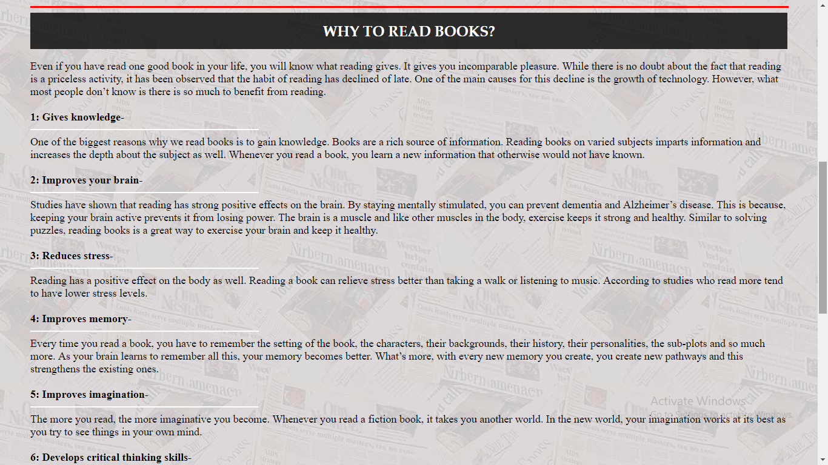

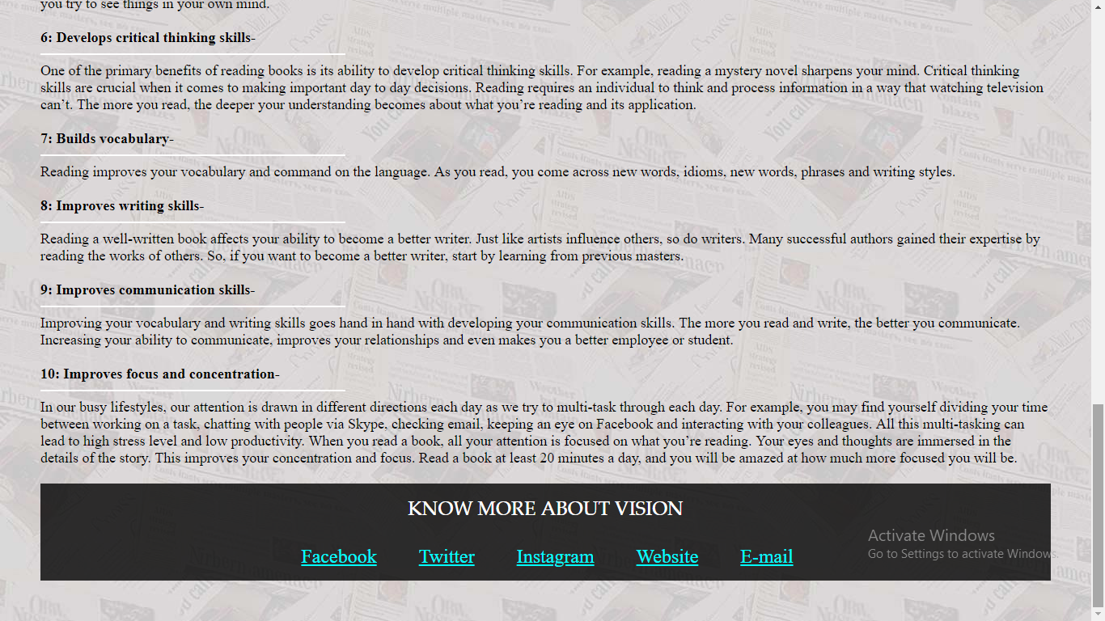

**About Us**

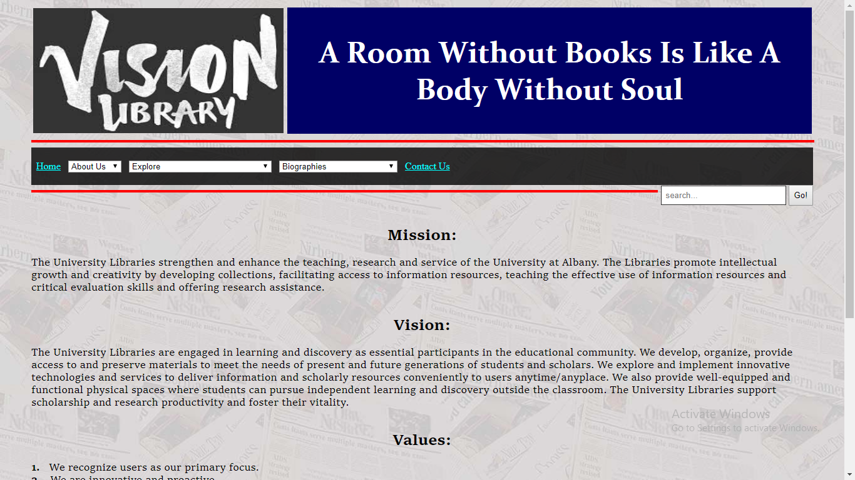

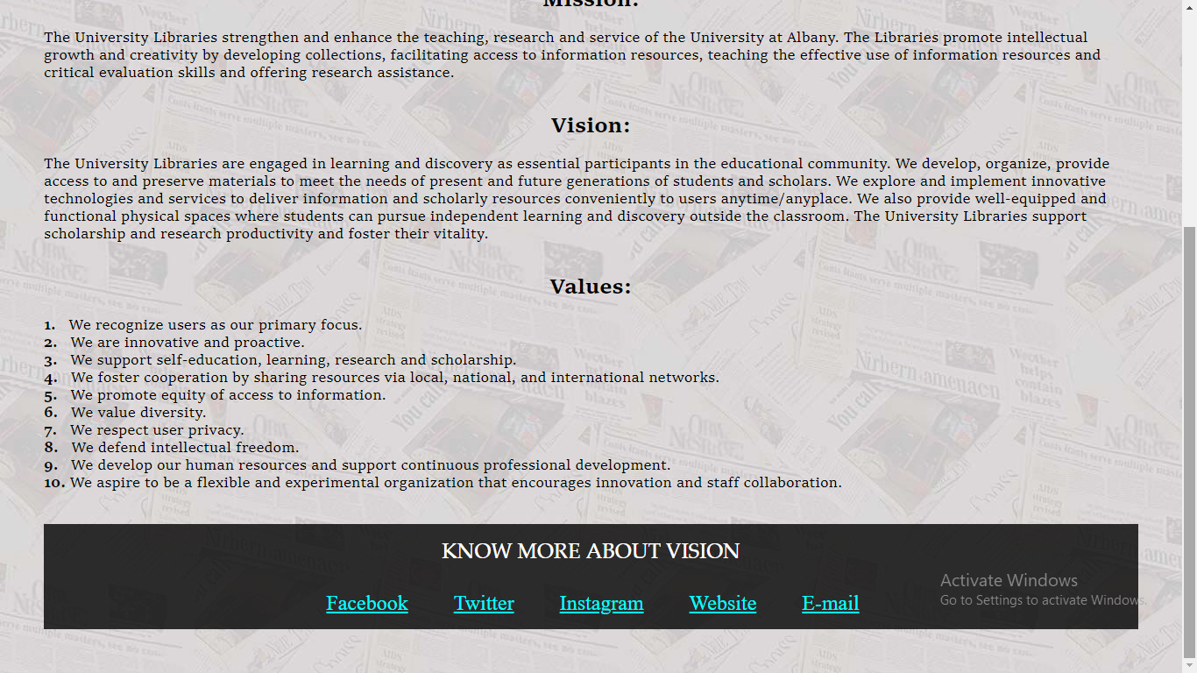

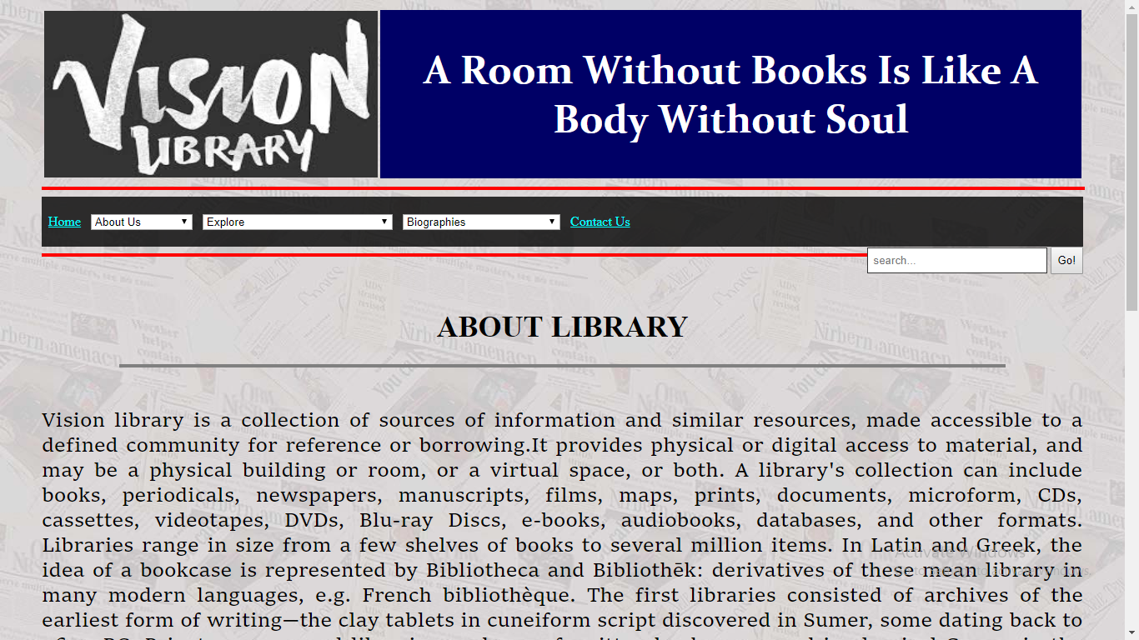

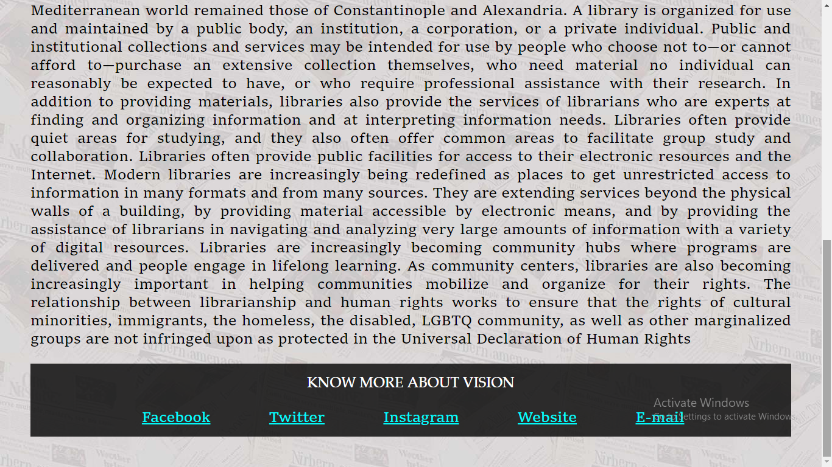

**Explore**

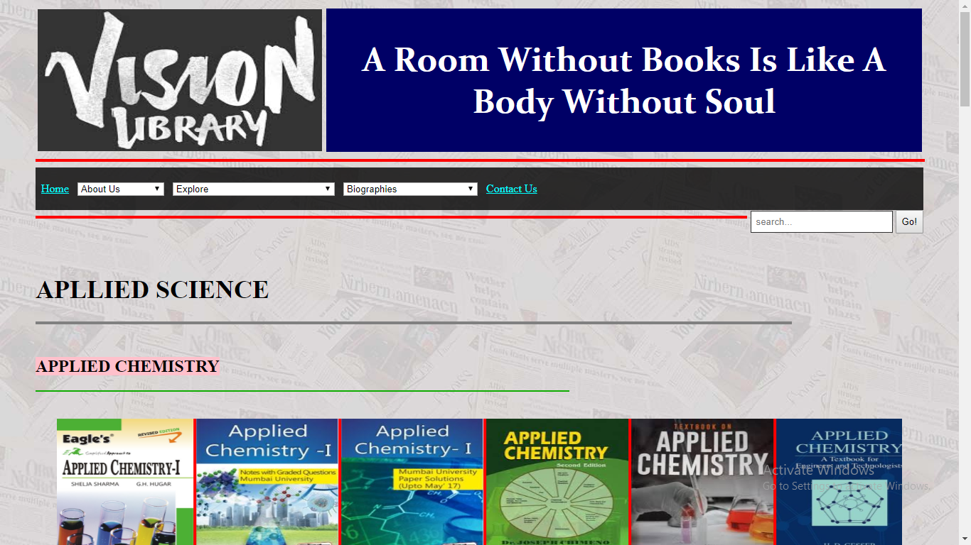

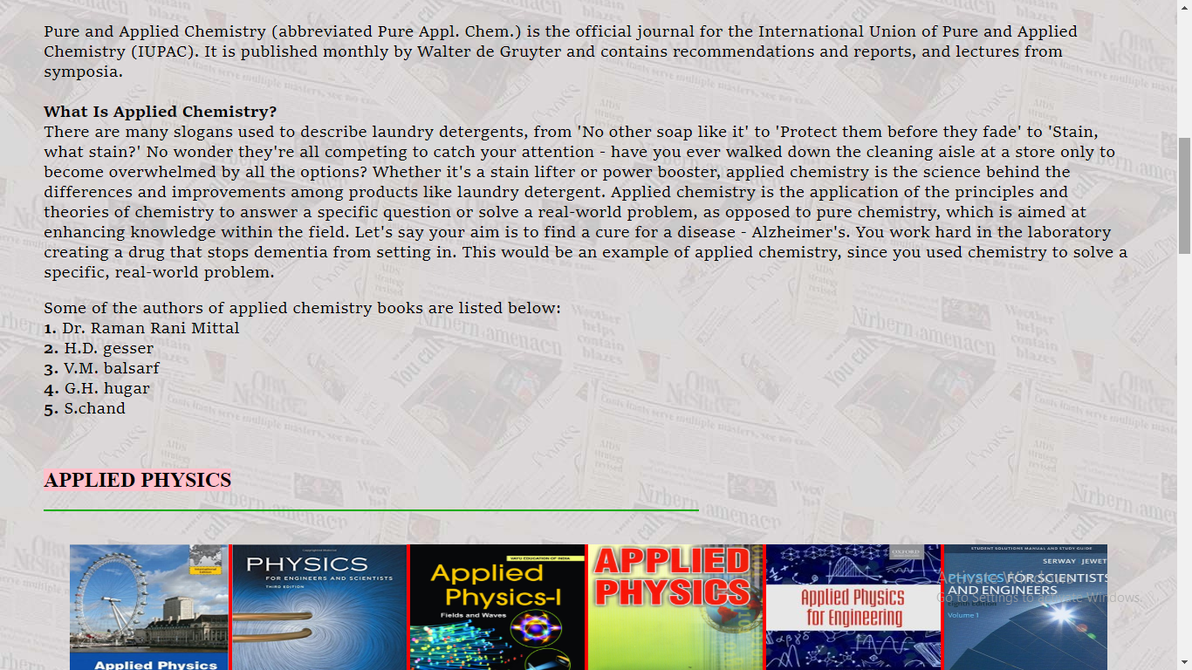

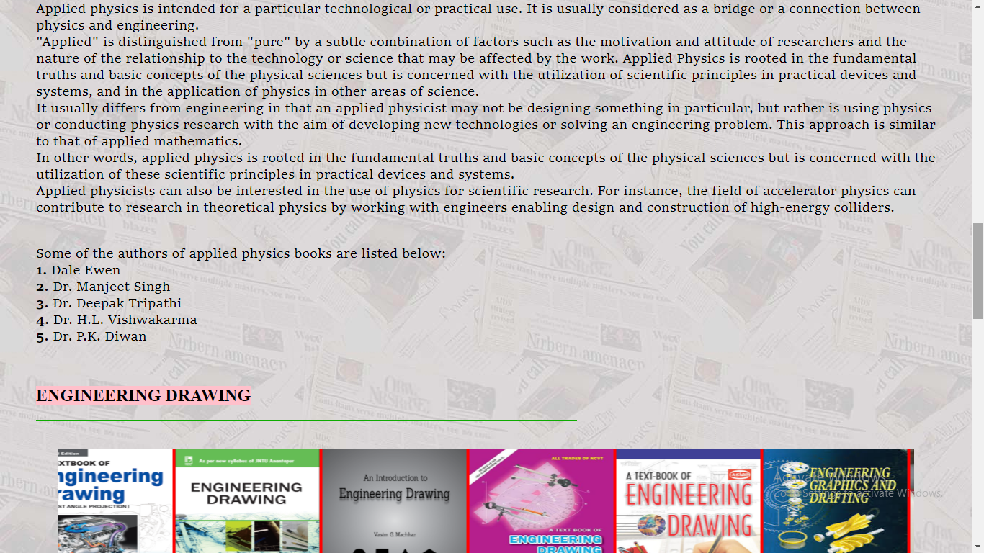

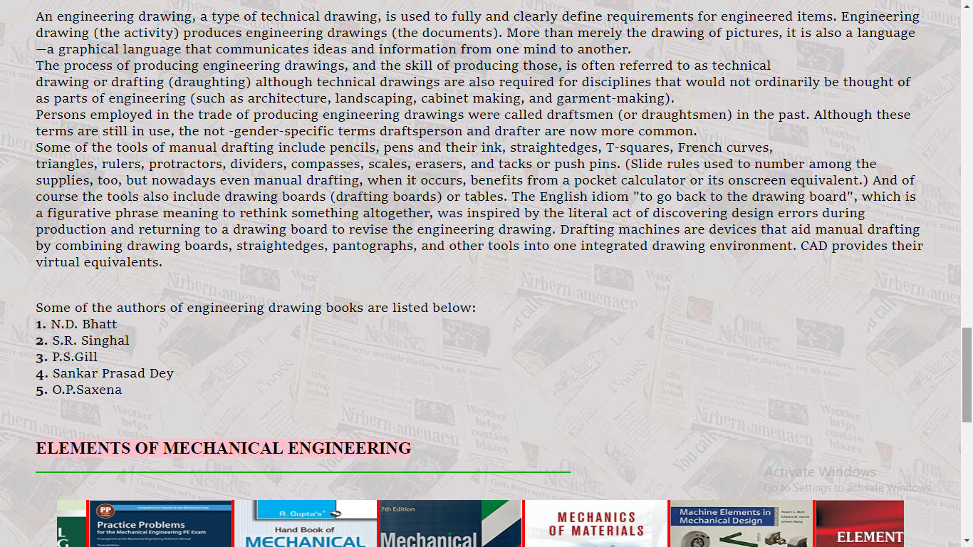

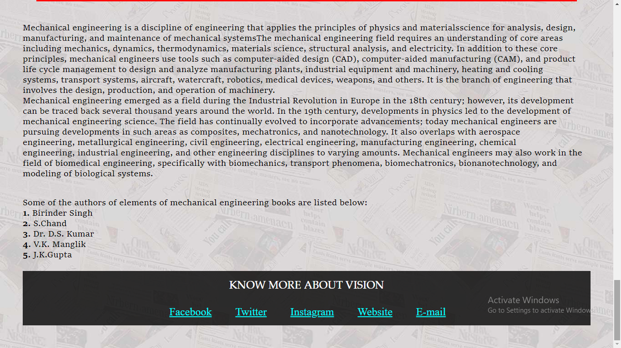

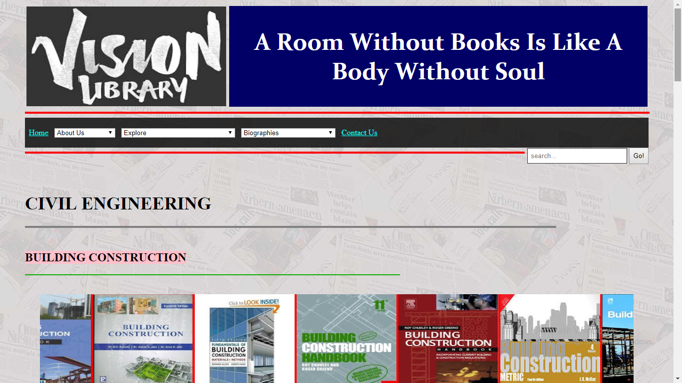

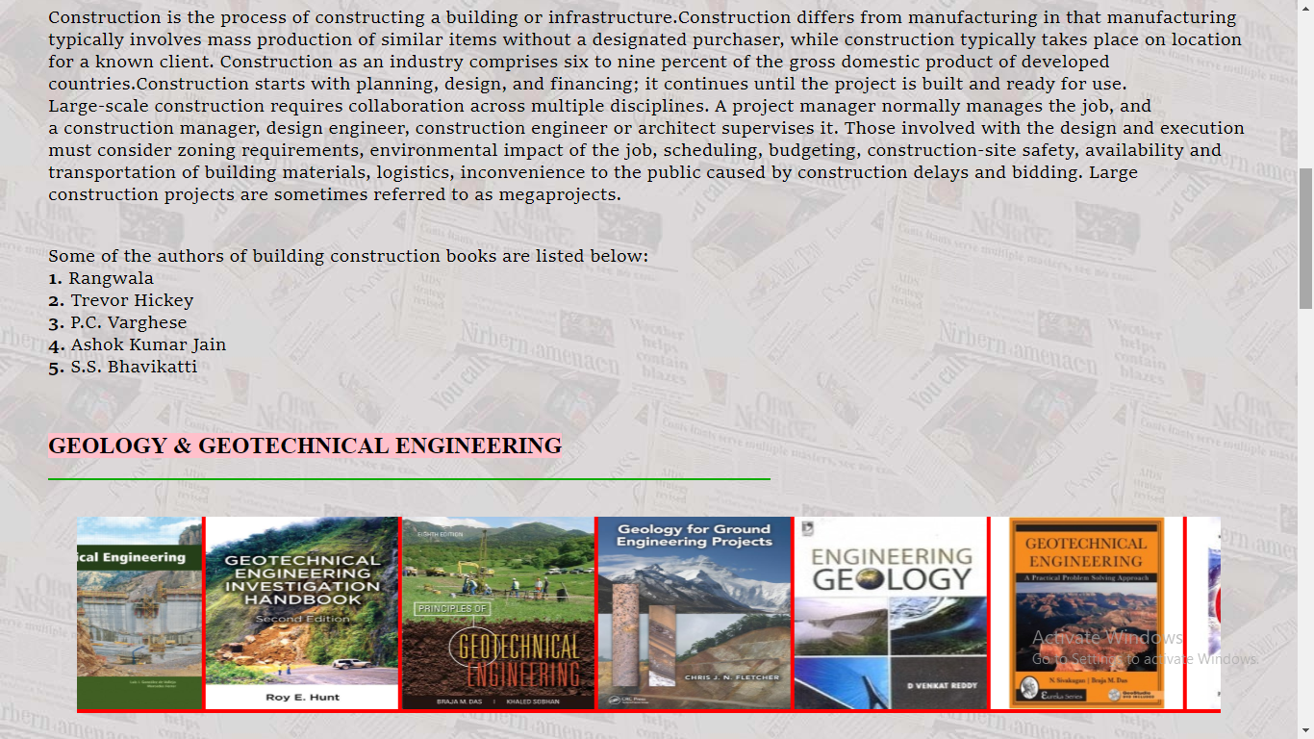

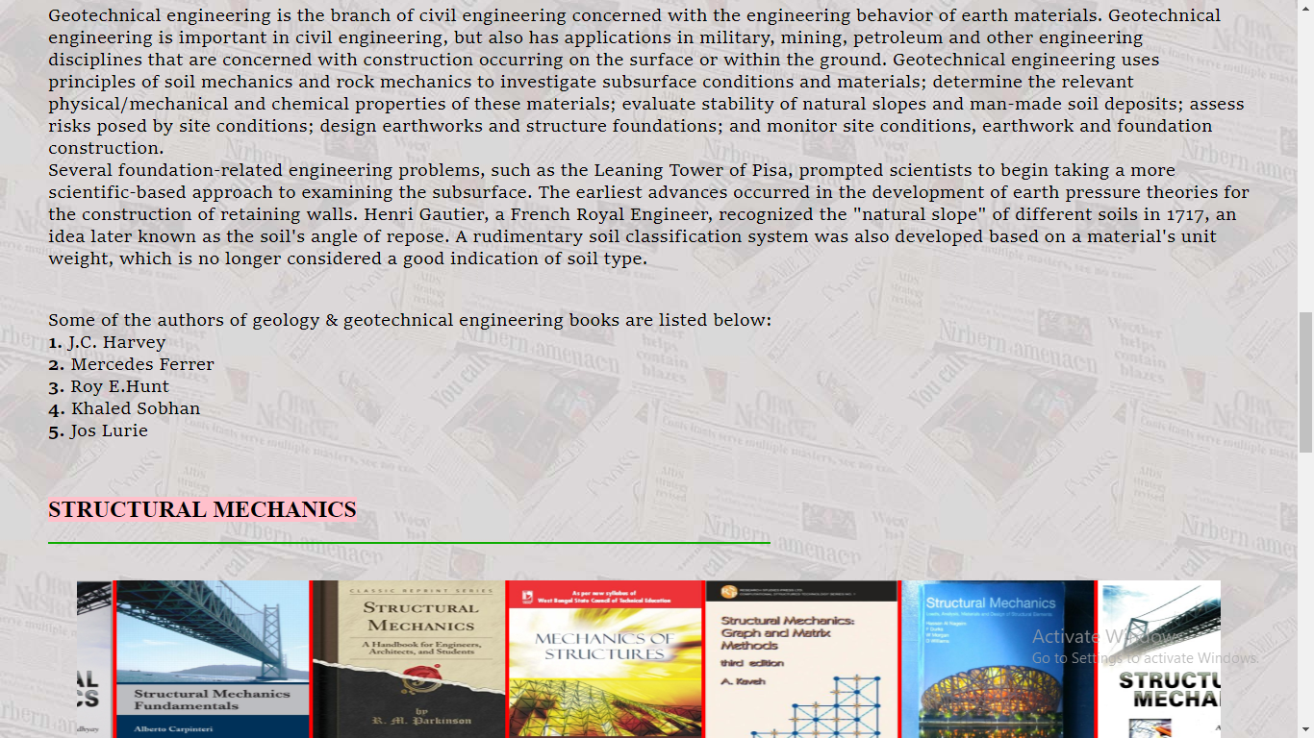

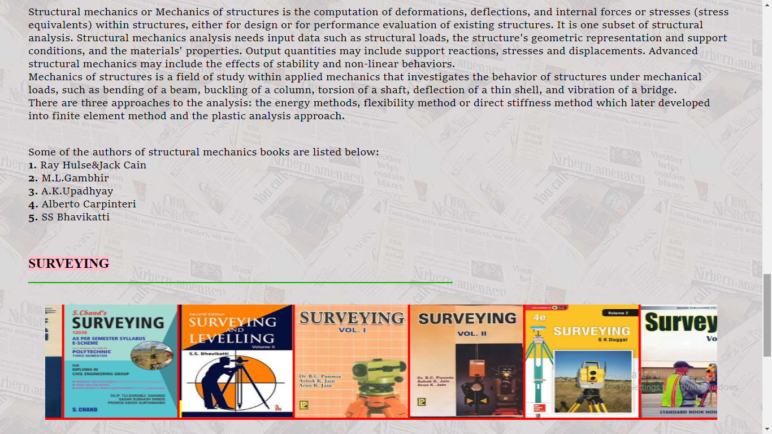

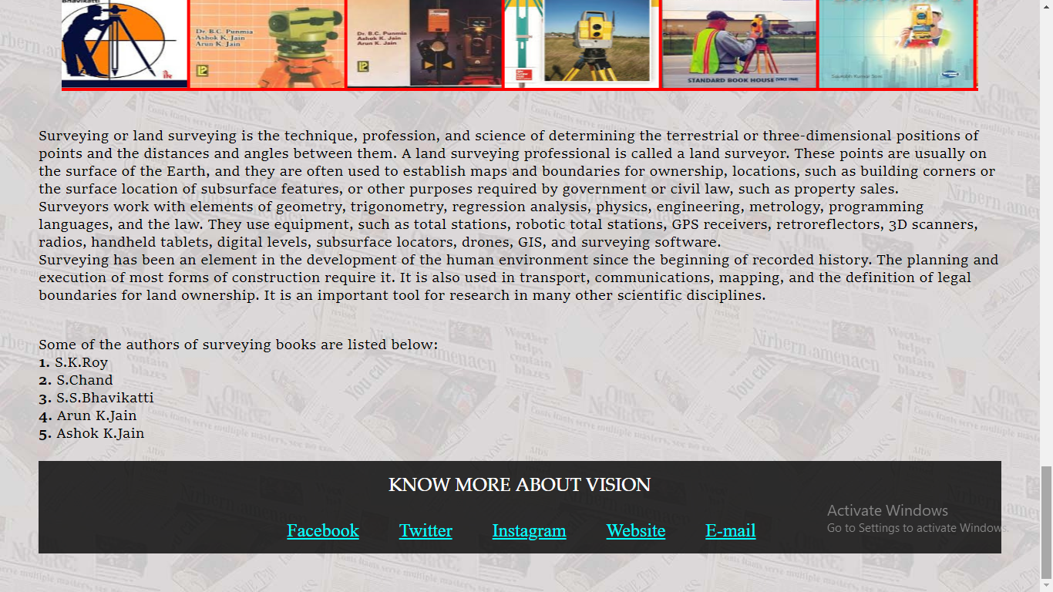

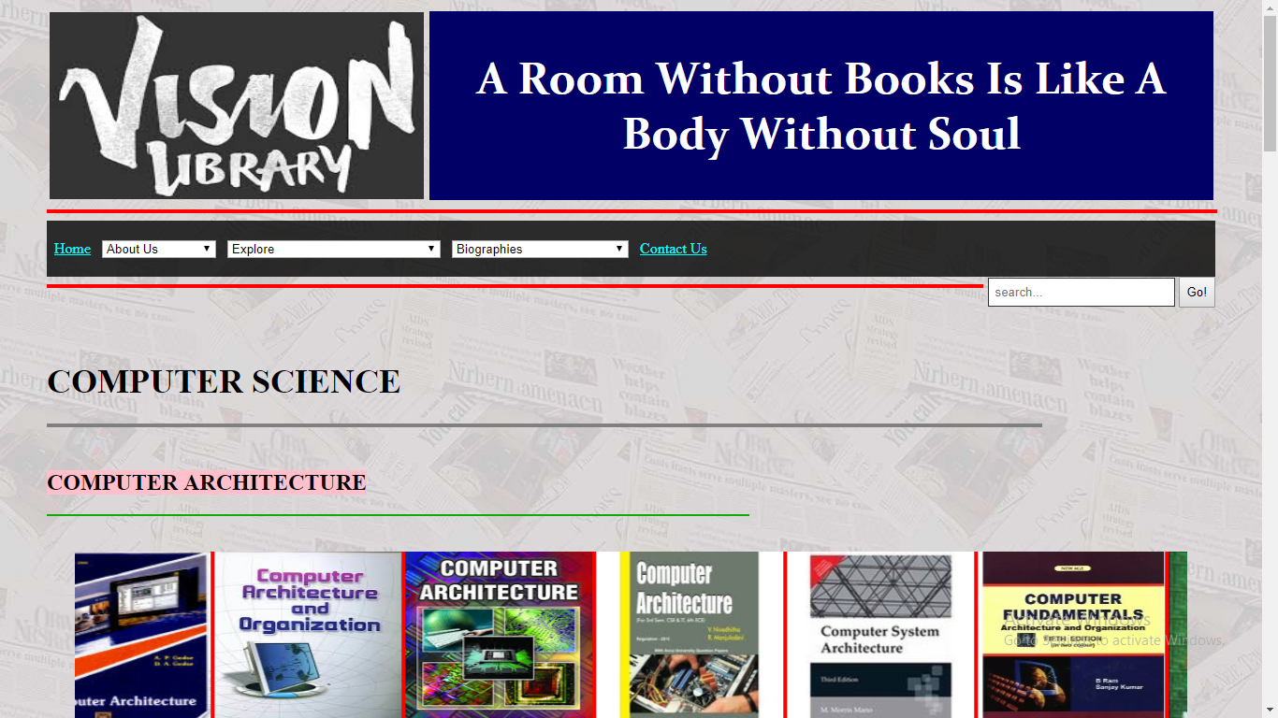

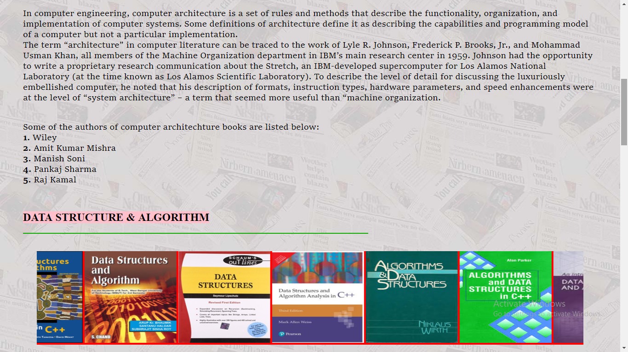

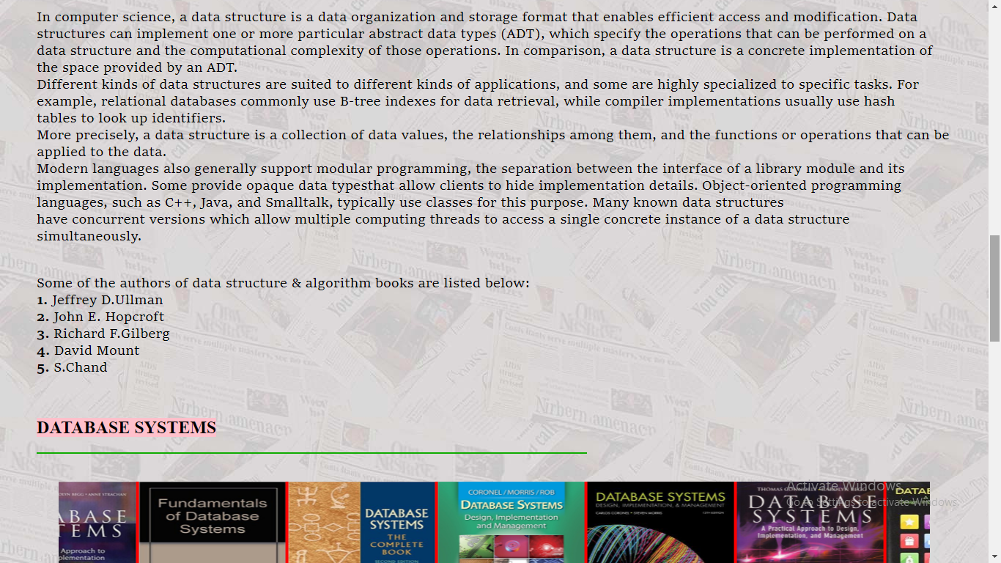

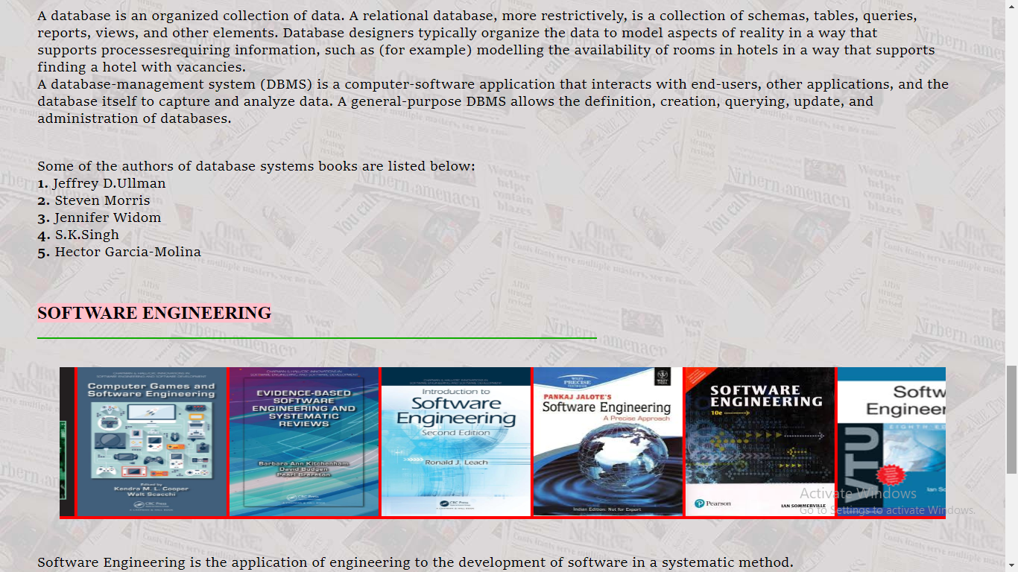

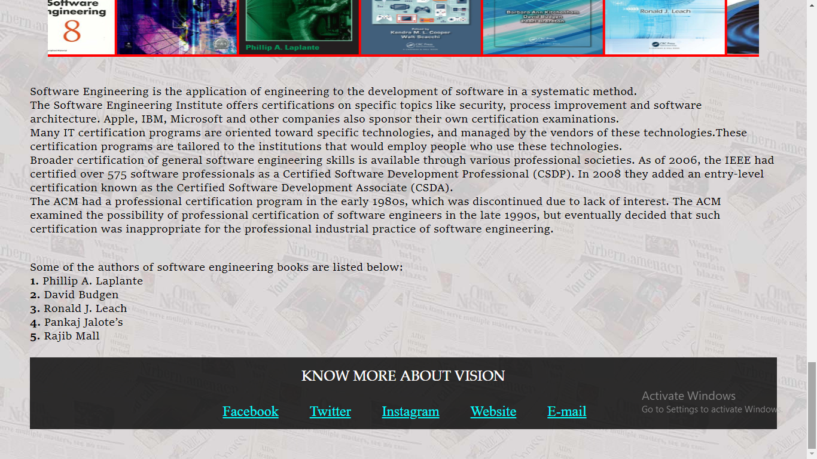

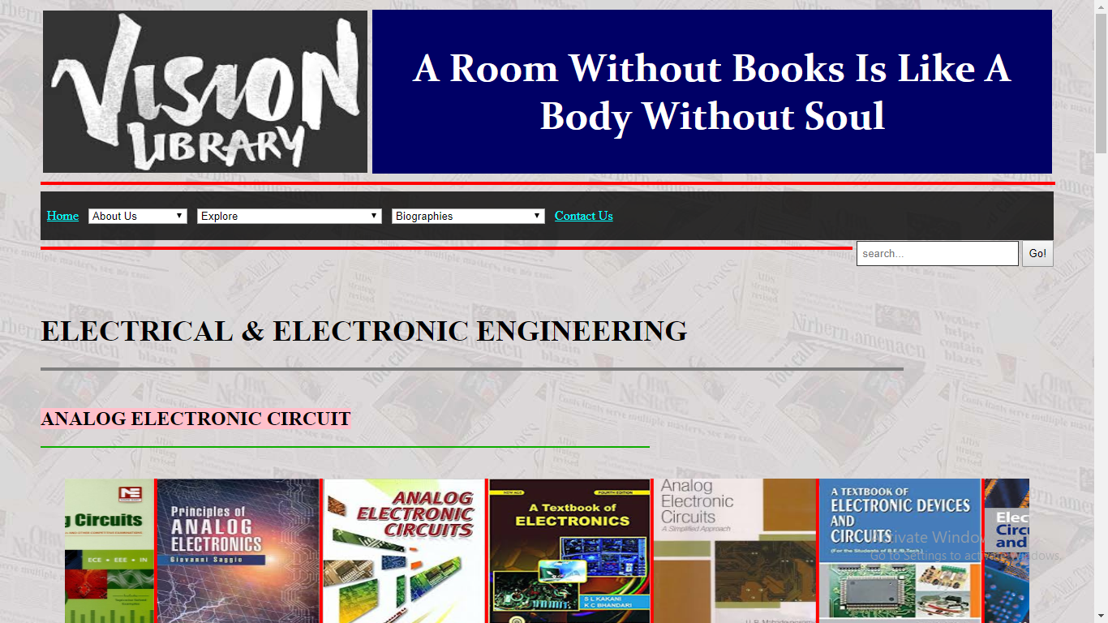

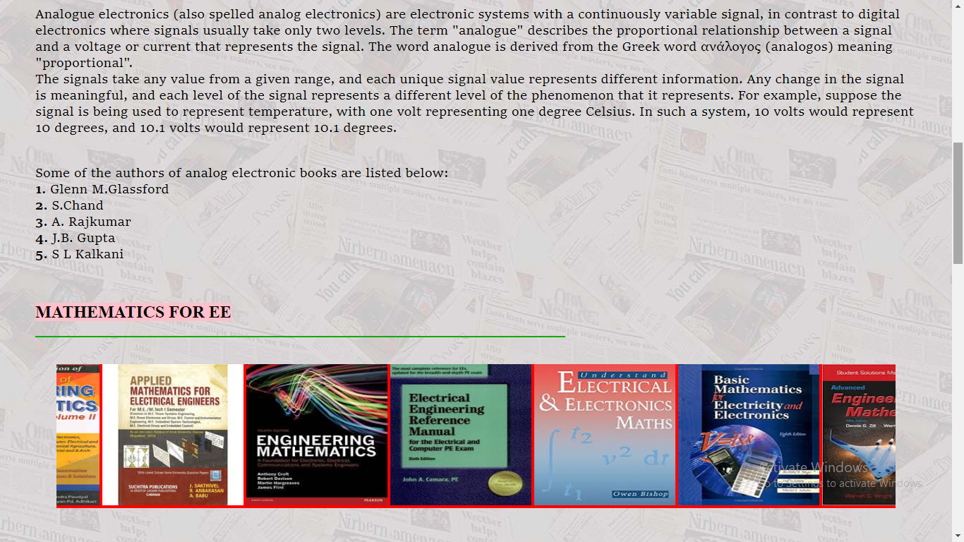

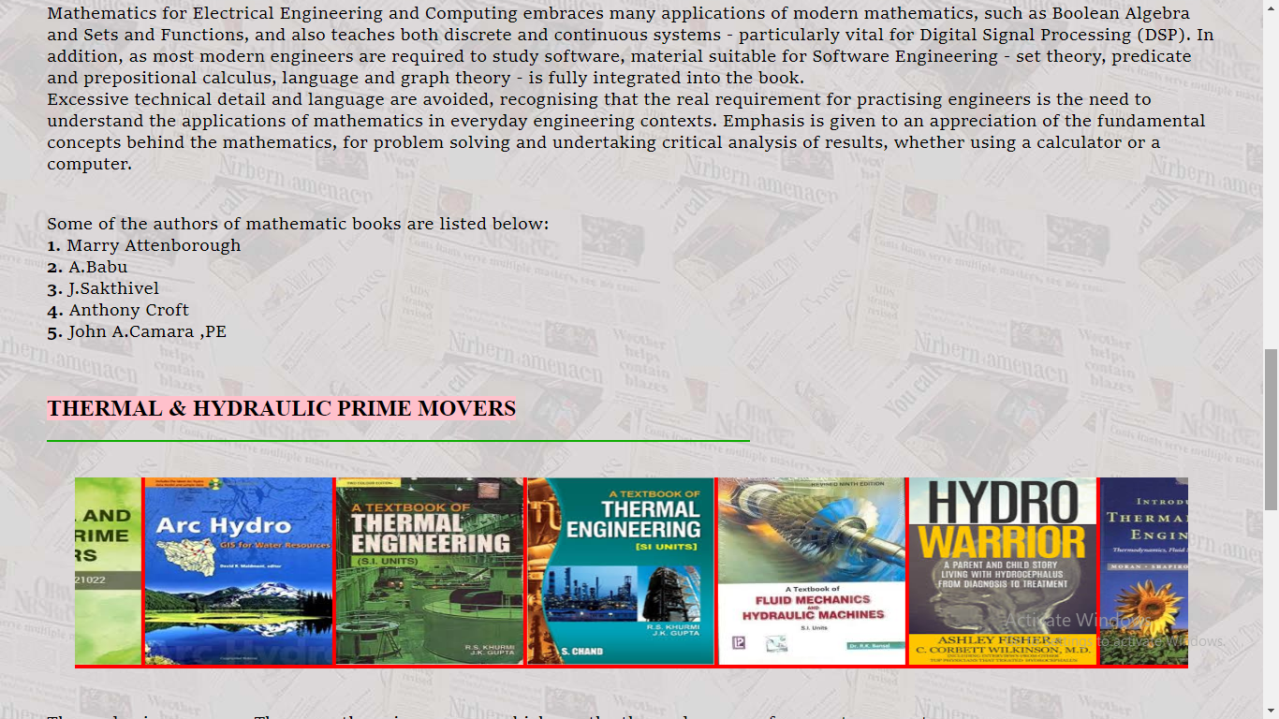

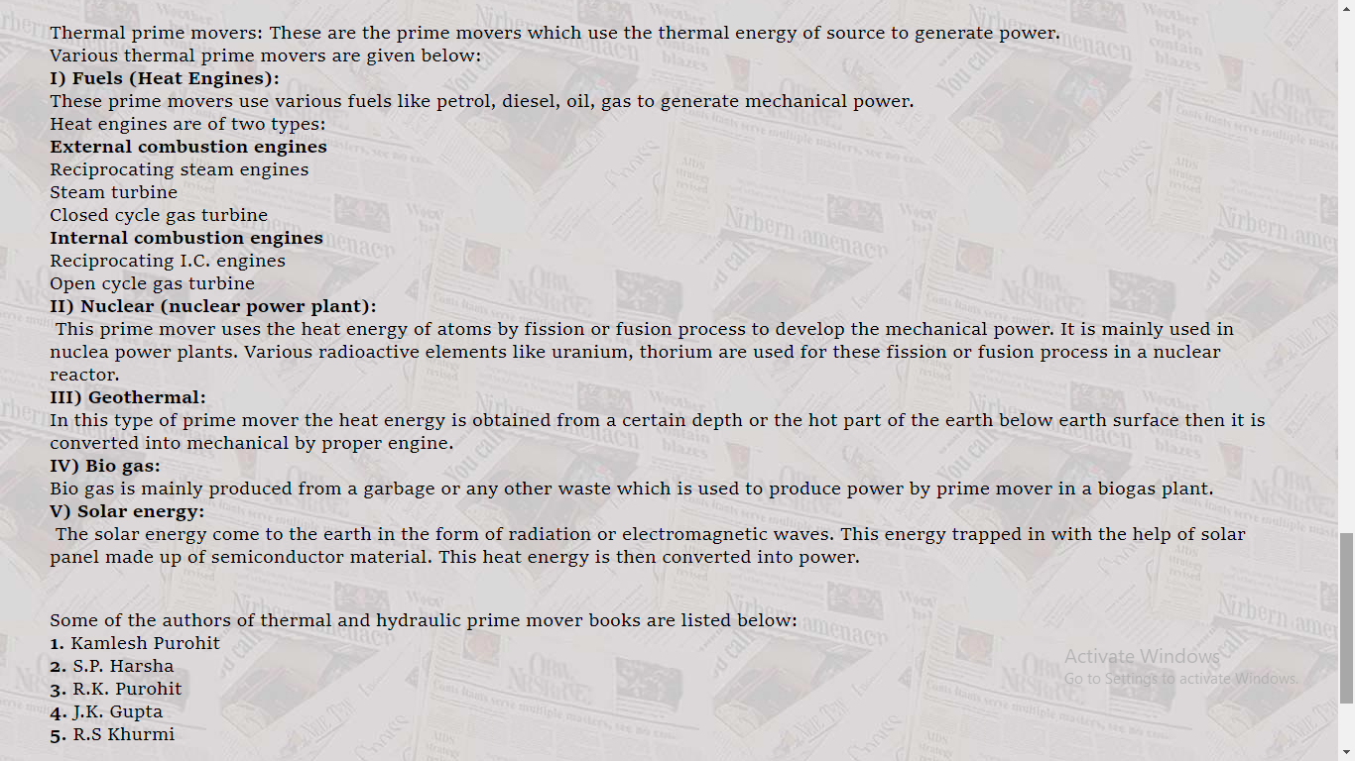

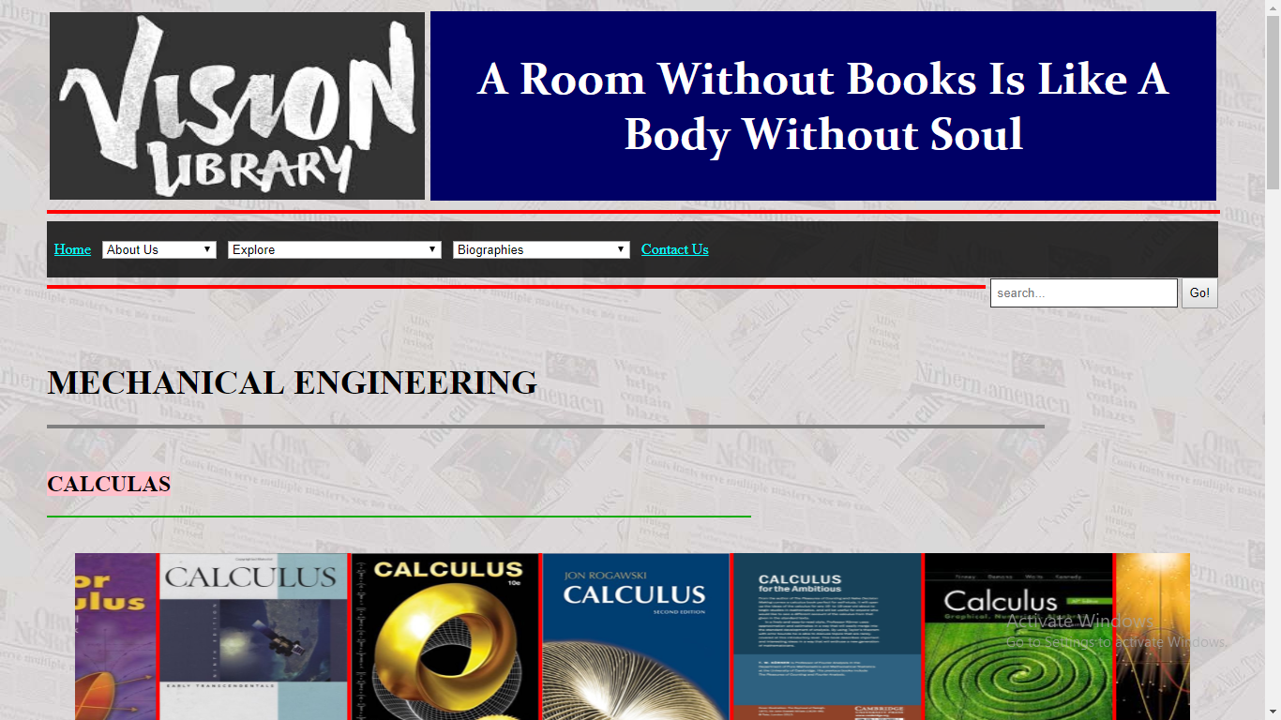

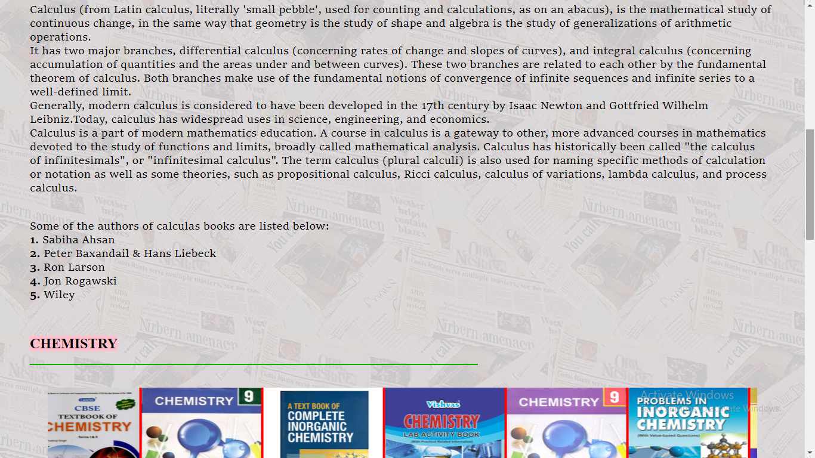

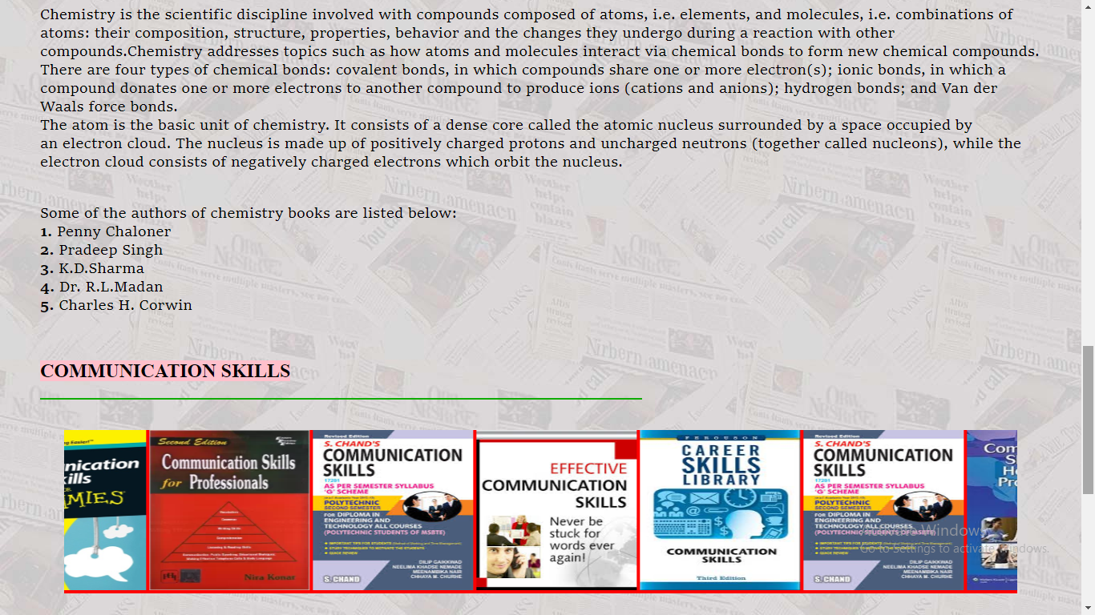

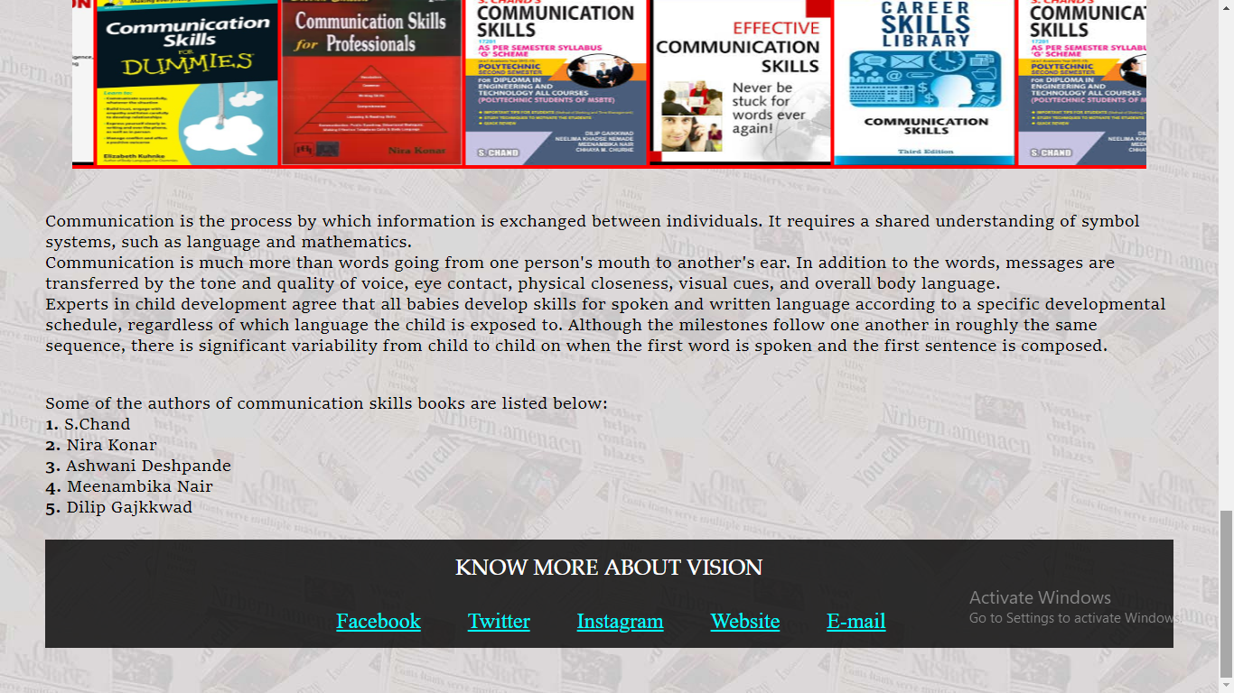

**Biographies**

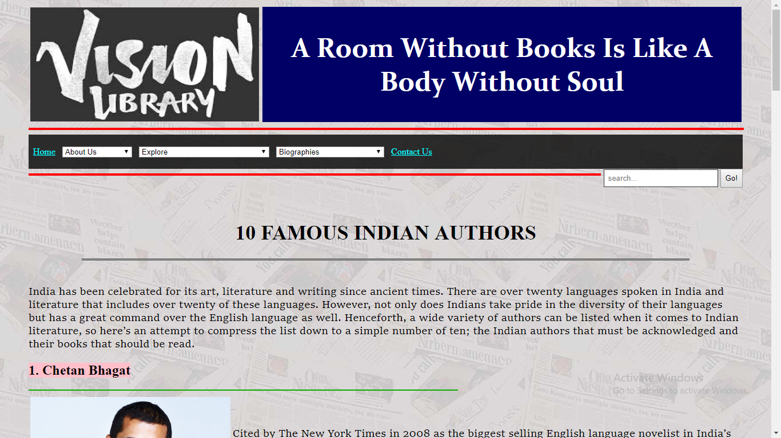

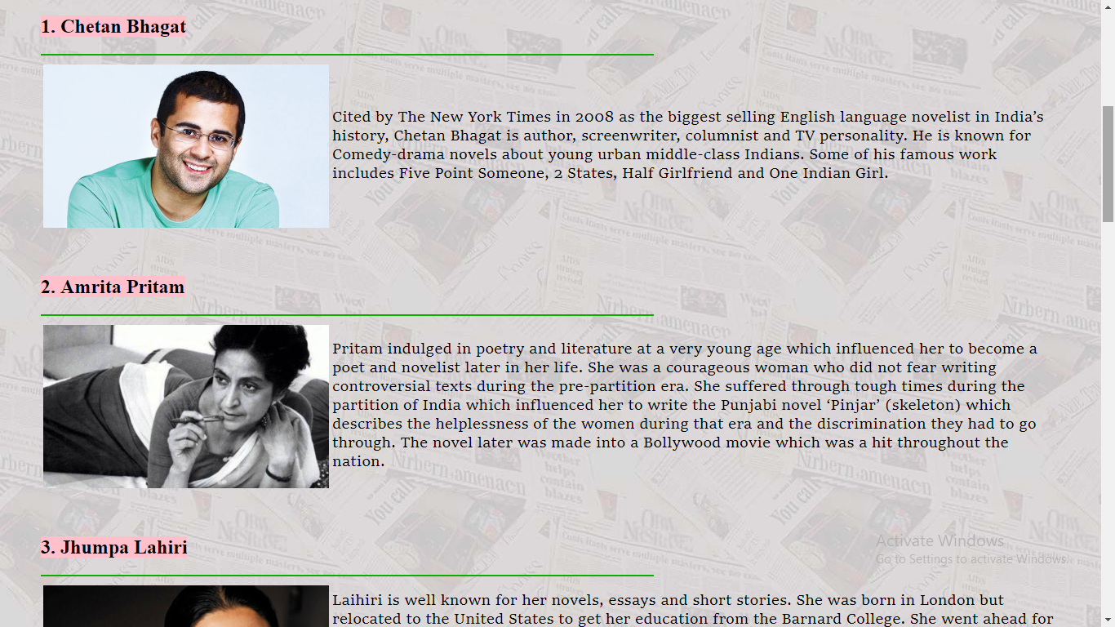

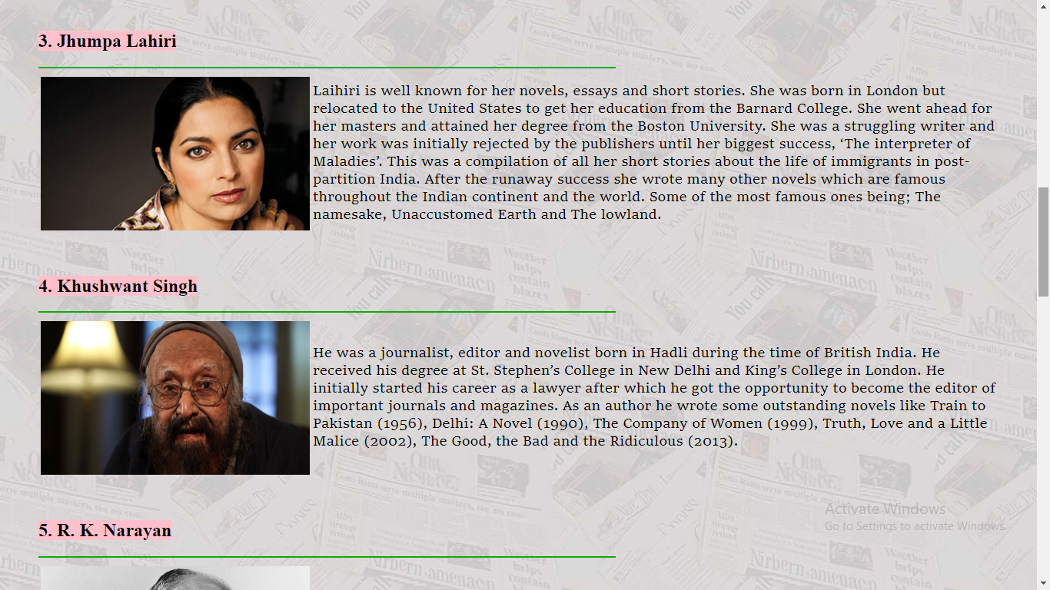

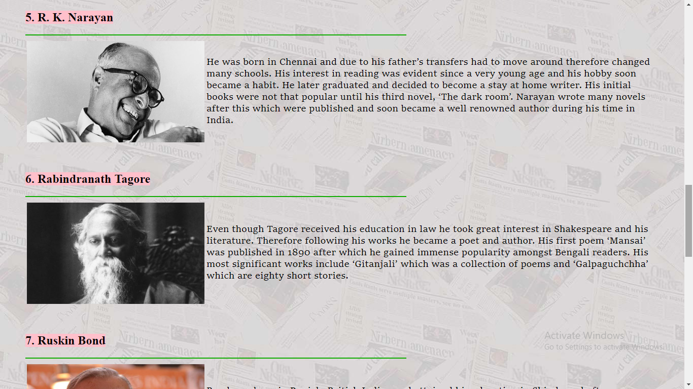

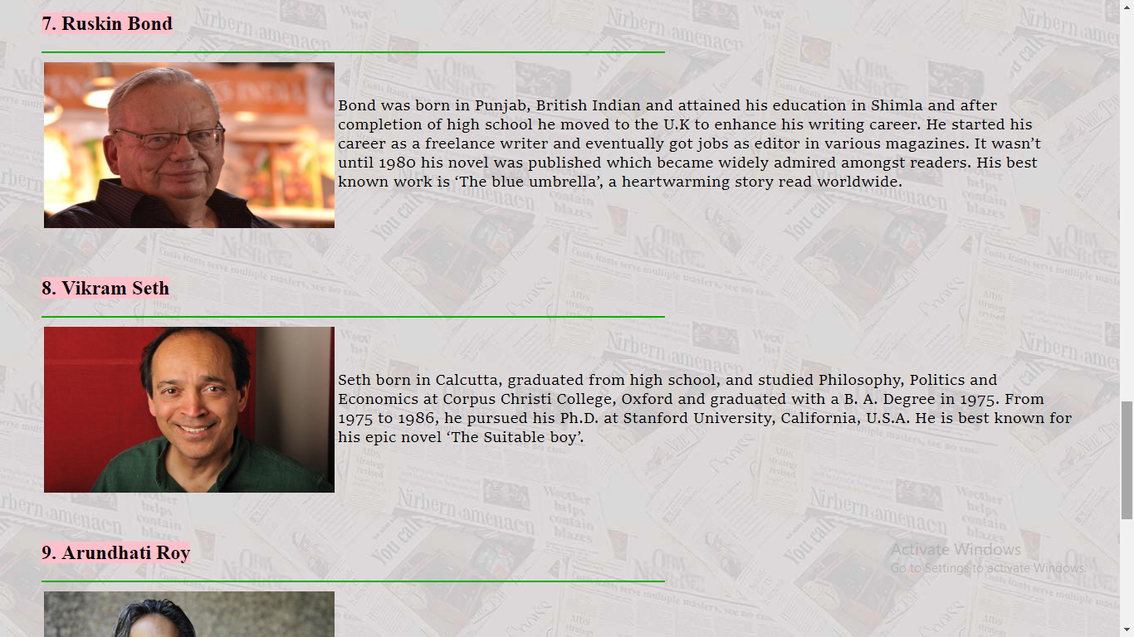

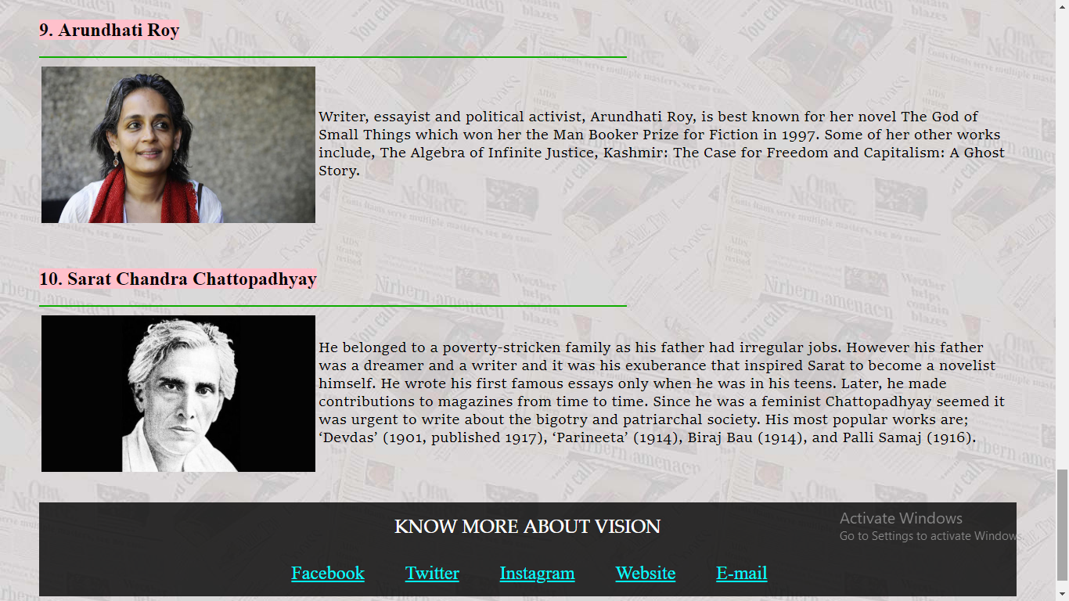

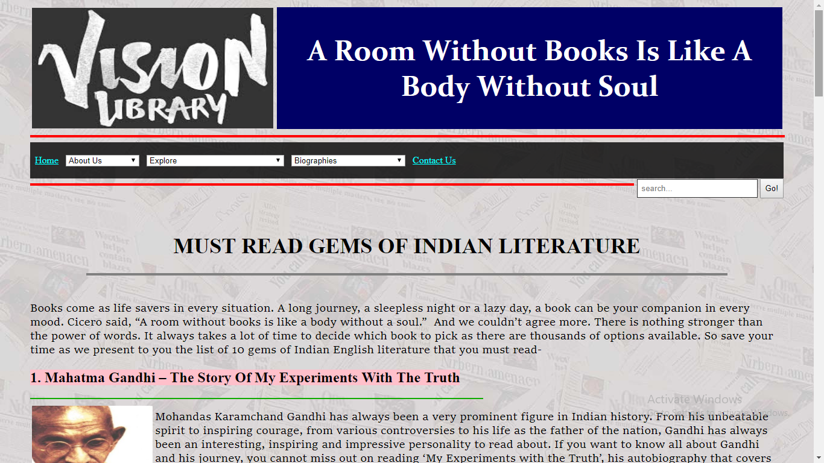

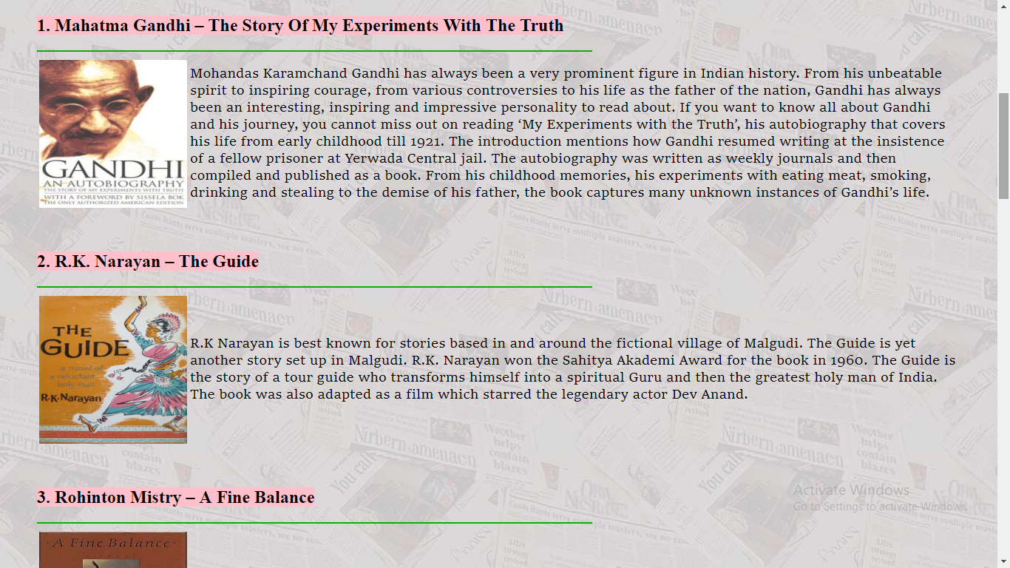

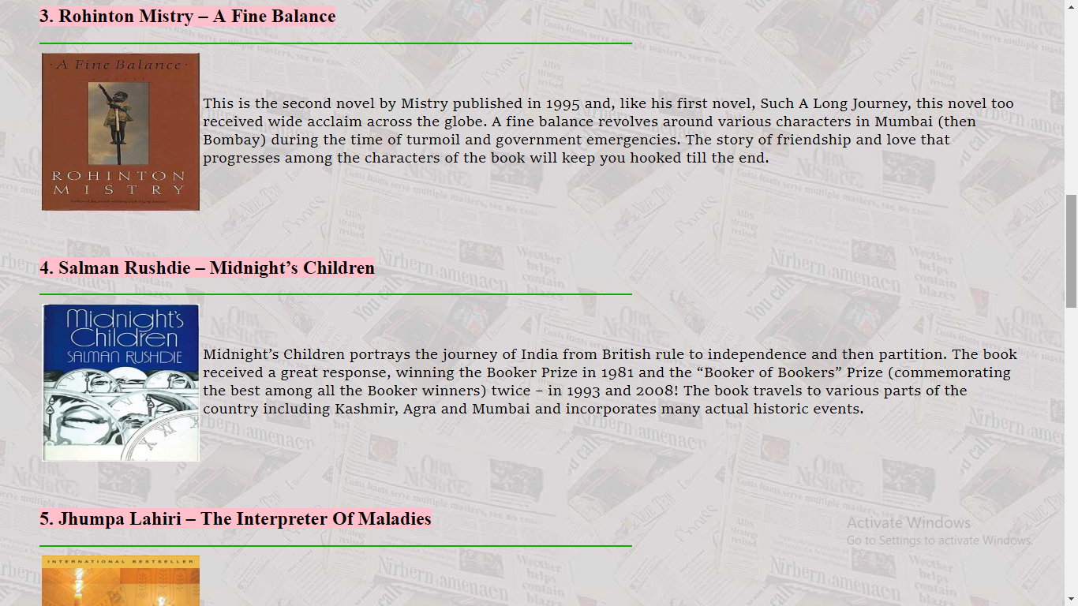

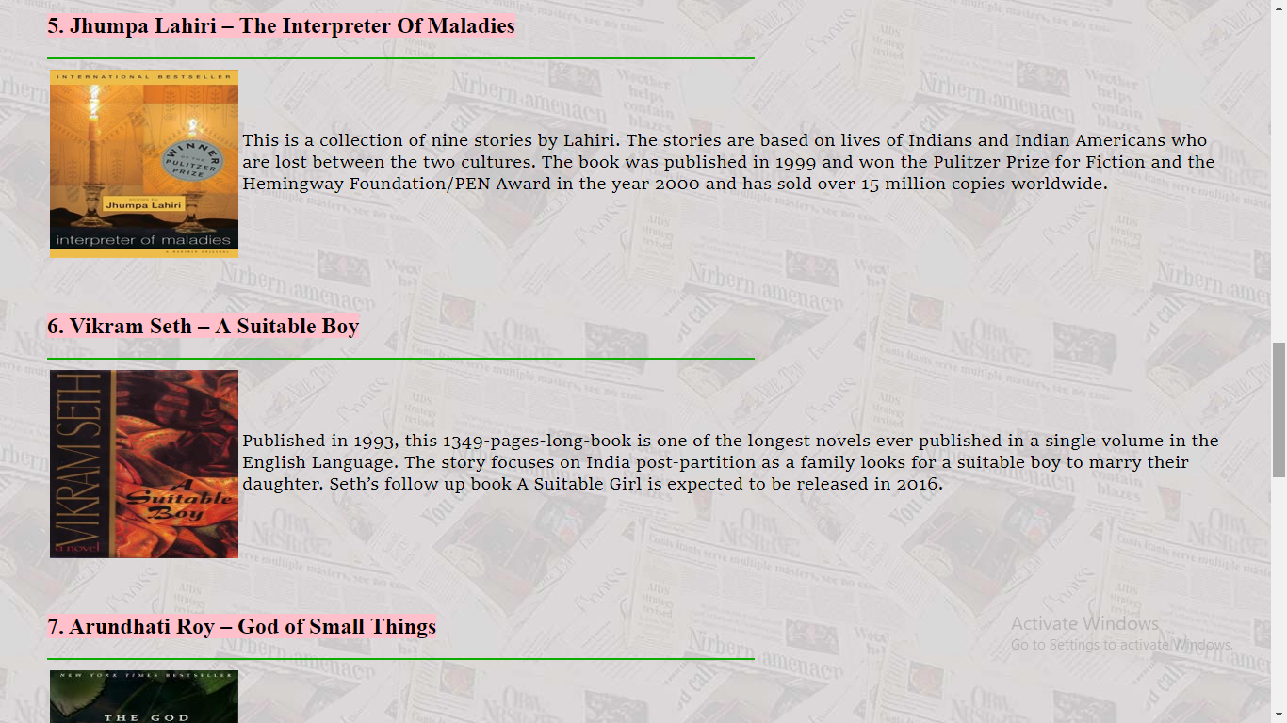

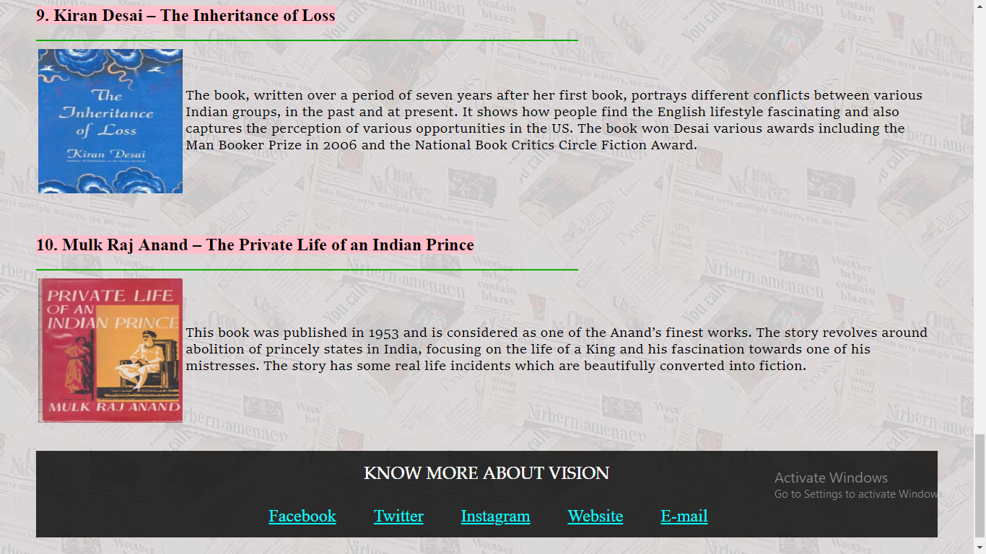

**Contact Us**

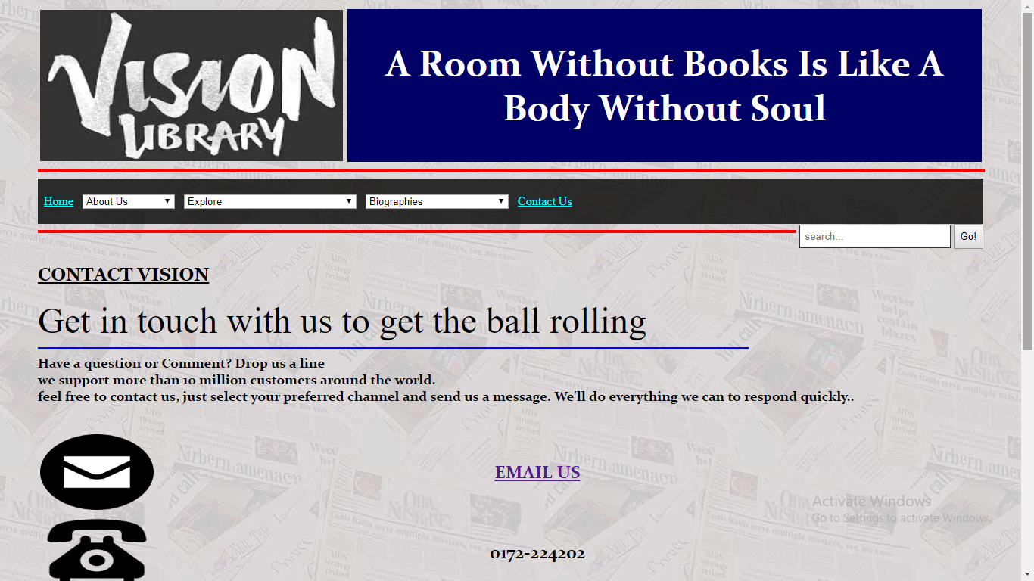

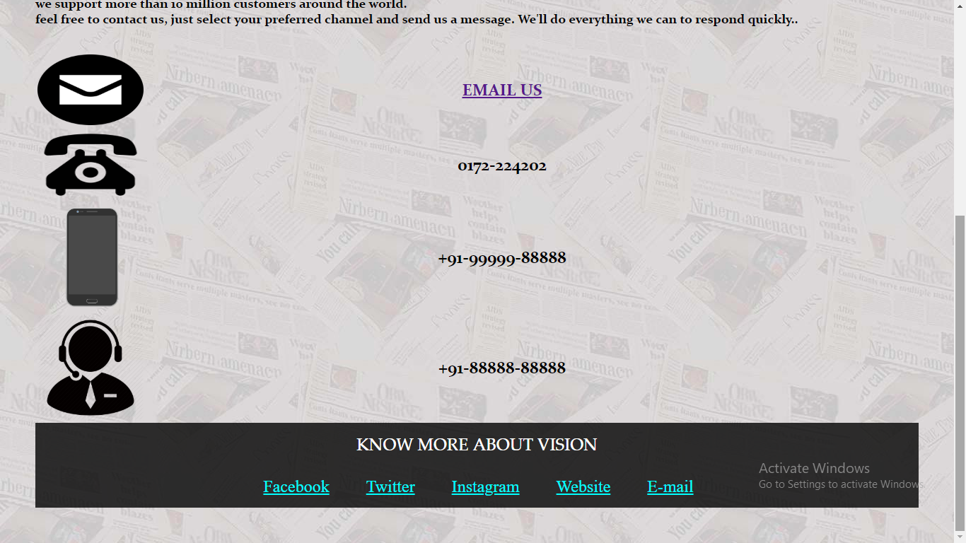

**REFRENCE** */* **BIBLIOGRAPHY**

[**www.w3schools.com**](http://www.w3schools.com)

**Wikipedia**

**Html tutorials**